Enable Cluster Passing for Custom Data Types– Functionality Tests
Revised: 11/4/2016 4:00 PM
TestStand Version: 2012 SP1

Author: Needhi
Feature Spec: No Spec
Dependencies: Perforce
Test Category: [ Functional ]

Description
Test that the display is correct for the dialog box for enabling cluster passing of a type. Also test that updates work properly.

Preparation
- Install LabVIEW.
- Install TestStand.
- Launch Sequence Editor and ensure LabVIEW is selected as the Development System in the LabVIEW Adapter.

Validation

- Create a VI\GVI which has a cluster connected to connector pane or use an existing GVI with cluster, Ex: from TS examples <TestStand Public>\Examples\Fundamentals\Passing Clusters to Code Modules\
- Create a new sequence file and insert an action step in MainSequence, calling LV\BLV code module containing the cluster.
- In the Module tab of the action step's Step Settings pane, click the Create Custom Data Type button under the Type field in the table of parameters.
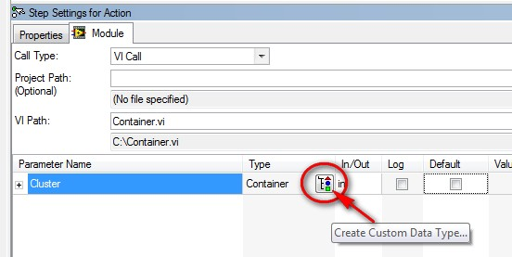
- Name your custom data type, then click Create in the Create Custom Data Type From Cluster dialog box.
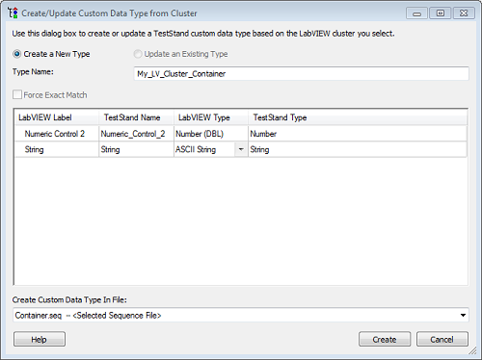
- In the Variables pane, right-click inside the Parameters container and select Insert Parameter » Type » <Your_Custom_Type>. This creates a parameter of the custom type defined in Step 3.
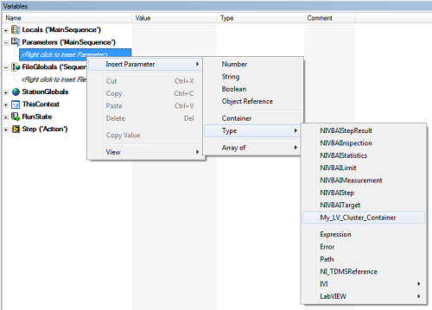
- Navigate back to the Module tab of the action step's Step Settings pane and assign the parameter created in Step 4 to the cluster being passed into LabVIEW. This is done by entering Parameter <Your_Parameter_Name> in the Value field of the table of parameters.
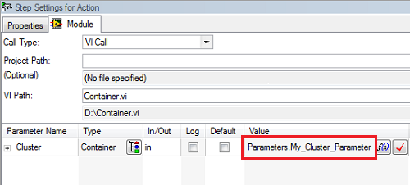
- Verify that the cluster passing option is enabled in the (LV\BLV) Cluster Passing tab of the properties dialog box for your custom data type. To access this dialog box, navigate to View » Types and select your sequence file from the tree in the View Types pane. Right-click your custom data type and select Properties.
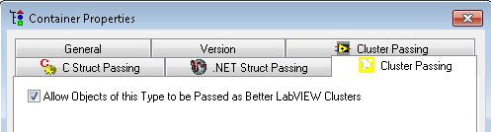
- Execute your test sequence and verify that it passes.
- Uncheck “Allow Objects of this Type to be Passed as Better LabVIEW Clusters” option and save the sequence file.
- Execute your test sequence and verify you get the following error:
Parameter 'Cluster':
The type of <Your_Custom_Type>. ' does not match the LabVIEW cluster 'Cluster', or cluster passing is disabled in the type definition of <Your_Custom_Type>.
Validate cluster passing for only selected elements of cluster works
- Create a new sequence file, Insert an Action step in the main sequence.
- Browse for <TS Examples>\Fundamentals\Passing Clusters to Code Modules\VI1.vi
- Create a custom data type with name “TestPassingCluster” from dialog by clicking on the Create/Update Custom Data Type button in the step settings panel:
- Open Type Palette (Ctrl+T) and select your sequence file in the tree view.
- In the Custom Data Types, right click on TestPassingCluster and select properties from context menu.
- Go to Cluster Passing tab for BLV in Properties dialog.
- Select Numeric from Property drop down and check Exclude when Passing Cluster.
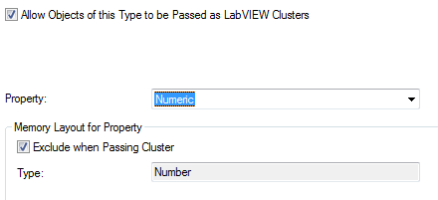
- Select Array and check Exclude when Passing Cluster. Save your changes and go back to sequence file.
- Open Variables pane from View >> Sequence File >> Variables.
- Insert a Local variable of type TestPassingCluster (Insert Local >> Type) name it TestType.
- In Step Settings pane, uncheck Default check box and specify Locals.TestType in Value column for Cluster (Container) input variable.
- Expand Cluster parameter and verify that you get error for Numeric and Array as shown below.
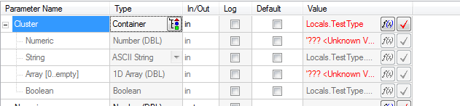
- Delete Locals.TestType from Cluster row. Verify that String and Boolean have Locals.TestType.String and Locals.TestType.Boolean specified as value respectively.
- Pass a valid numeric value for Numeric control, and an array of numbers for array control in cluster.
- Execute the test sequence and verify that execution completes without any error.

